2.94: a) The speed of any object falling a distance H – h in free fall is
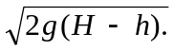b) The acceleration needed to bring an object from speed v to rest over a
distance h is 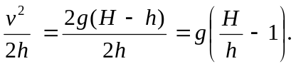
c)
